Wind Speed
Instrument: Anemometer
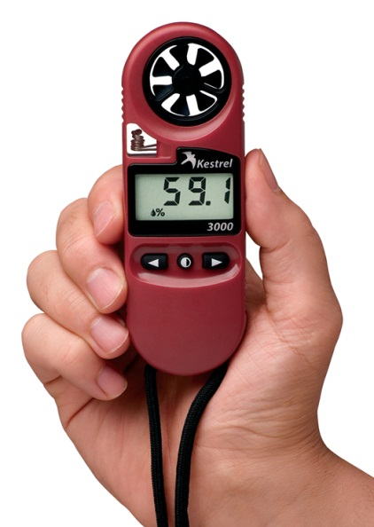
Method:
1. Turn on. Press the left button
to turn on the unit.
4. Select the wind speed icon.
5. Turn off automatically.
Record Wind Speed and direction in booklet

Measuring Humidity

Instrument: hygrometer/wet and dry bulb
Thermometer or Kestrel
Method:
• Read air temperature on the wet bulb
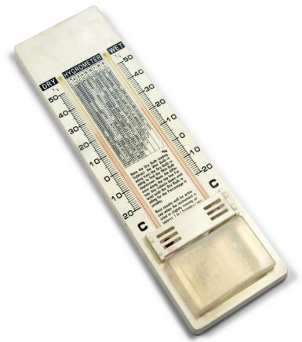
thermometer and subtract it from the reading
of the dry bulb.
• Calculate the difference, match the
temperature difference on the table.
• Follow that column until level with the dry bulb
reading.
• Write the number as a % of air moisture.
Can check humidity with kestrel. Scroll to icon %.

Measuring Light Intensity
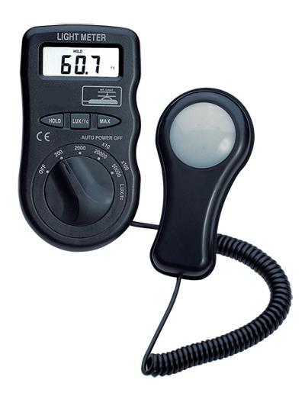
Instrument: Lux meter
Method:
• Place scale button on x100.
• Turn on power.
• Place light sensor upwards & flat.
• If sunny, place sensor in shade and take a
reading. Then place in the sun and take a
reading. Average the result and multiply this
number by 100. Record your result.
• If overcast, any situation for the sensor is
appropriate.

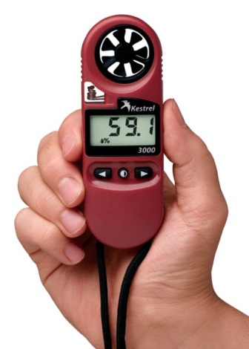
Air temp

Instrument: Kestrel or thermometer
Method:
2. Turn on. Press the button to turn on the unit.
3. Select the temperature reading.
4. Record temp. OR
1. Read temp off thermometer

Soil Texture

Equipment: soil types identification (below), trowel,
water
Method:
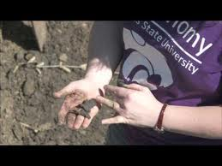
• Take a sample of soil (enough to fit in the palm of
your hand).
• Remove vegetation and rocks from the sample.
• Add water and roll into a ball (called a bolus).
• Move sample between fingers near ear. If gritty it contains SAND – SANDY
If it can make a ball – contains LOAM
IF it can make a snake that holds together when pushed over fingers, it contains clay.

Measuring pH
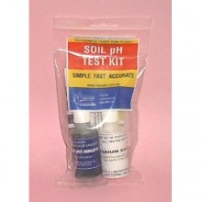
Equipment: mixing tray, pH colour chart, universal
indicator, barium sulphate, trowel, gloves
Method:
• Place a soil sample on plastic tile.
Vegetation and rocks should be removed from
the sample.
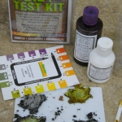
• Place 3 drops of universal indicator on the
sample and mix.
• Add soil or indicator until a pasty consistency is
achieved.
• Sprinkle barium sulphate over the paste but
don’t mix.
• Compare the colour of the barium sulphate with
the pH colour chart and record the pH result.

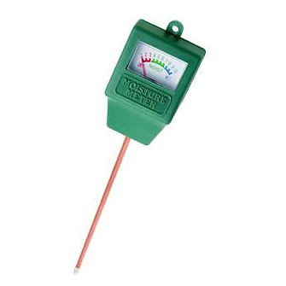
Soil Moisture

Equipment: Green Moisture Metre
Method:
Insert probe tip to 5cm to root level.
Record soil moisture.

Soil Temperature
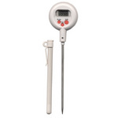
Equipment: thermometer probe
Method:
Dig a hole with stick about 5cm deep in soil.
• Place the thermometer in the soil so that the
metal stick is in the soil.
• Take a reading after 1 minute with the
thermometer still in the soil
• Record the temperature reading as °C.

Aspect

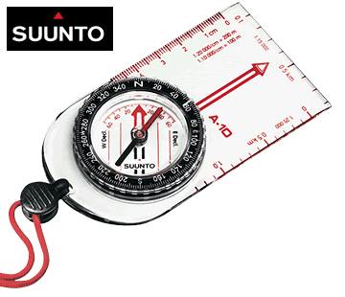
Aspect is the direction that a slope faces. It identifies
the steepest down slope direction at a location on a surface.
It can be thought of as slope direction or the compass direction a hill faces.
Instrument: Compass
Method:
1. Stand facing downhill – the way a ball would roll if set away down the hill.
2. Point your compass in the direction of the fall-line – i.e. with direction of travel indicator pointing downhill.
3. Rotate the compass housing so that the arrow lines up with the pointer of the compass needle.

Measuring Slope

Instrument: clinometer
Method:
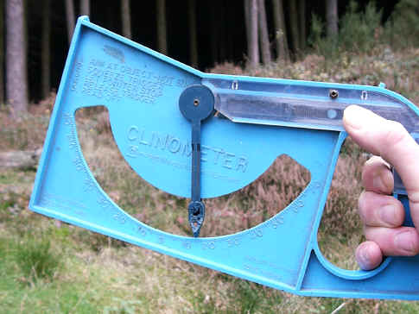
• Find the direction of the slope.
• Stand 2 team members side by side with one
holding the clinometer. Determine the eye
height of the person with the clinometer relative
to the other person.
• Stand 10 metres apart along the slope.
• Aim clinometer at the eye height position. Use
the sight on top of the clinometer.
• Press in the trigger and release when steady.
• Read the angle of the slope and record on worksheet.

