Investigation planner: Stages 2 and 3

Name: Sample answer for turbidity investigation
Date:

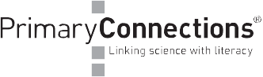
Other members of your team:

Question for investigation  The difference in the turbidity between the dam and the creek. |  | What do you think will happen? Explain why.  Dependent on student responses, possibilities include:  - The dam will be cleaner because it’s a bigger water body (incorrect in this case)  - The creek will be cleaner because its flowing and the banks are lined with trees (correct)
What things (variables) are you going to:
Change  Location of water body / aquatic habitat | Measure/observe  Turbidity – dirt in the water  Observe the presence of livestock, evidence of erosion and vegetation. |  | Keep the same  Sampling technique  Time and weather (both samples taken within an hour)  Apparatus (turbidity tube)
How will you make it a fair test?  Controlling variable- Use the same sampling procedure for collection of water. Whole class samples both locations, only compare paired samples i.e same observer  Water - sample from the middle of water, do not scrape dirt from bottom or slicks from surface)  Tube reading (take the tube reading in the shade, read the NTU as the first number under the water level) |  | Draw the equipment you will use and show how it will be set up.
Write and draw about your observations in your science journal (and record your results in a table).

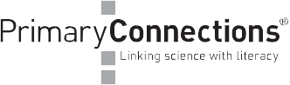

Presenting results

Can you show your results in a graph?

Explaining results

When you changed location / habitat what happened to the …turbidity......……..………….........?

Turbidity was higher in the dam than the creek.
Why did this happen?  -erosion at the dam, livestock access to dam  -creek is well vegetated | Did the results match your prediction? If not what was different?

Evaluating the investigation

What problems did you have in doing this investigation?
-accurate sampling without stirring up the turbidity
- controlling water depth as a variable
How could you improve this investigation (fairness, accuracy)?
- take more samples at both locations
-regular monitoring through the year

