Niches & competition
What an ecological niche is. How species with overlapping niches compete for resources. Resource partitioning to reduce competition.
https://www.khanacademy.org/science/biology/ecology/community-ecosystem-ecology/a/niches-competition

Key points:
- In interspecies competition, two species use the same limited resource. Competition has a negative effect on both of the species (-/- interaction).
- A species' niche is basically its ecological role, which is defined by the set of conditions, resources, and interactions it needs (or can make use of).
- The competitive exclusion principle says that two species can't coexist if they occupy exactly the same niche (competing for identical resources).
- Two species whose niches overlap may evolve by natural selection to have more distinct niches, resulting in resource partitioning.

Introduction
Humans compete with other humans all the time – for jobs, athletic prizes, dates, you name it. But do we compete with other species? If you've ever gone camping and had you food stolen by an enterprising raccoon, bear, or other critter, you've had a little taste of interspecific competition – competition between members of different species that use overlapping, limited resources.
Resources are often limited in a habitat, and many species may compete to get ahold of them. For instance, plants in a garden may compete with each other for soil nutrients, water, and light. The overall effect of interspecific competition is negative for both species that participate (a -/- interaction). That is, each species would do better if the other species weren't there.
In this article, we'll look at the concept of an ecological niche and see how species having similar niches can lead to competition. We'll also see how species can evolve by natural selection to occupy more different niches, thus divvying up resources and minimizing competition.

The niche concept
A species' niche is its ecological role or "way of life," which is defined by the full set of conditions, resources, and interactions it needs (or can make use of)1^1​1​​start superscript, 1, end superscript. Each species fits into an ecological community in its own special way and has its own tolerable ranges for many environmental factors. For example, a fish species' niche might be defined partly by ranges of salinity (saltiness), pH (acidity), and temperature it can tolerate, as well as the types of food it can eat.
[Is that the only way to define a niche?]
Nope! If you look at different sources, you'll likely find slightly (or significantly) different definitions of this term. For instance, some people emphasize that the niche is the set of resources an organism needs or can utilize, while others emphasize that the niche is an organism's role or position in a community.
I would argue that these definitions can be seen as two different sides of the same coin: if we describe an organism's position in a community in sufficiently minute detail, we'll end up mentioning all of its biotic and abiotic requirements and interactions, and vice versa. I've tried to capture this idea in the definition given in the main text. However, it would be a good idea to make sure you are familiar with the definition of "niche" used by your teacher or textbook.

Niche as an n-dimensional hypervolume
Some ecologists define a niche in a more specific and mathematical way: as an n-dimensional hypervolume. I actually think this is a really cool and intuitive way of thinking about a niche, and though it may not be what you are learning about in intro bio, you may still find it interesting and helpful.
In this model, an organism's niche is defined by many intersecting axes. Each axis represents a different variable – for instance, if we were talking about a fish, we might use temperature, pH, and salinity as three of our axes. On each axis, the fish would be able to survive only within a certain range of values. By seeing where the ranges on the different axes intersected, we could define a 3D space representing the organism's niche in relation to those variables.
But the niche of our fish species wouldn't be fully defined by just three axes. For instance, what about levels of dissolved nutrients in the water? What about presence or levels of algae and other microorganisms? If you think about it, there are many different variables that define the conditions under which a fish can live. This is why we need an n-dimensional hyperspace (with n referring to the many axes representing different variables) in order to define a niche.
Even though we can't visualize >3 dimensions very well (or I can't, anyway!), we can extrapolate from the 3D example to get an intuitive understanding of how a niche represents the intersection of many different tolerance ranges.
As we'll see, two organisms with exactly the same niche can't survive in the same habitat (because they compete for exactly the same resources, so one will drive the other to extinction). However, species whose niches only partly overlap may be able to coexist. Also, over long periods of time, they may evolve to make use of more different, or less overlapping, sets of resources.

Competitive exclusion principle
The competitive exclusion principle tells us that two species can't have exactly the same niche in a habitat and stably coexist. That's because species with identical niches also have identical needs, which means they would compete for precisely the same resources.
A famous example of the competitive exclusion principle is shown in the figure below, which features two types of single-celled microorganisms, Paramecium aurelia and Paramecium caudatum. When grown individually in the lab, both species thrive. But when they are grown in the same test tube (habitat) with a fixed amount of nutrients, both grow more poorly and P. aurelia eventually outcompetes P. caudatum for food, leading to P. caudatum's extinction.

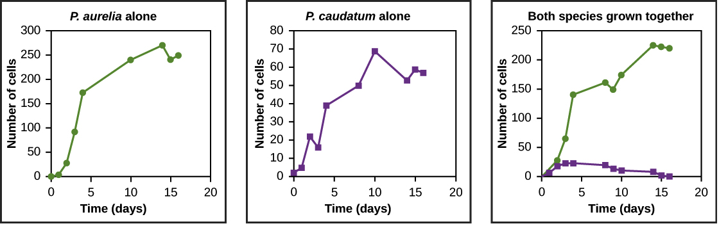
Graphs a, b, and c all plot number of cells versus time in days. In Graph (a), P. aurelia is grown alone. In graph (b), P. caudatum is grown alone. In graph (c), both species are grown together. When grown together, the two species both exhibit logistic growth and grow to a relatively high cell density. When the two species are grown together, P. aurelia shows logistic growth to nearly the same cell density as it exhibited when grown alone, but P. caudatum hardly grows at all, and eventually its population drops to zero.
Image modified from "Community ecology: Figure 7," by OpenStax College, Concepts of Biology, CC BY 4.0.
In nature, it's rarely the case that two species occupy exactly identical niches. However, the greater the extent to which two species' niches overlap, the stronger the competition between them will tend to be2^2​2​​start superscript, 2, end superscript.

Resource partitioning
Competitive exclusion may be avoided if one or both of the competing species evolves to use a different resource, occupy a different area of the habitat, or feed during a different time of day. The result of this kind of evolution is that two similar species use largely non-overlapping resources and thus have different niches. This is called resource partitioning, and it helps the species coexist because there is less direct competition between them.
The anole lizards found on the island of Puerto Rico are a good example of resource partitioning. In this group, natural selection has led to the evolution of different species that make use of different resources. The figure below shows resource partitioning among 11111111 species of anole lizards. Each species lives in its own preferred habitat, which is defined by type and height of vegetation (trees, shrubs, cactus, etc.), sunlight, and moisture, among other factors.

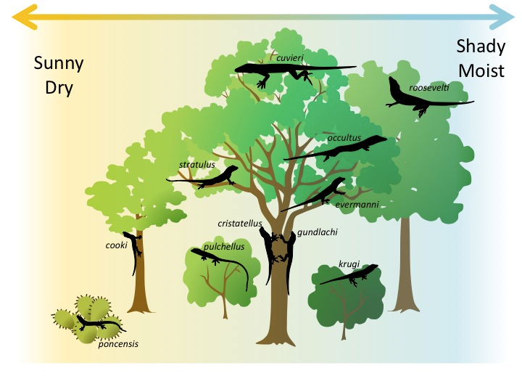

Diagram representing resource partitioning among species of anole lizards. Some live high in a tree, others in the middle, others on the trunk. Other anole species live in bushes or cactuses. Also, some species live in a sunnier, drier environment, while others live in a shadier, moister environment. There are 11 species pictured in all, each with a slightly different type of environment it occupies.
Image credit: "Community ecology: Figure 9, by Eva Horne, modified from Williams et al.3^3​3​​start superscript, 3, end superscript, source article is CC BY 4.0.

