Bandicoots

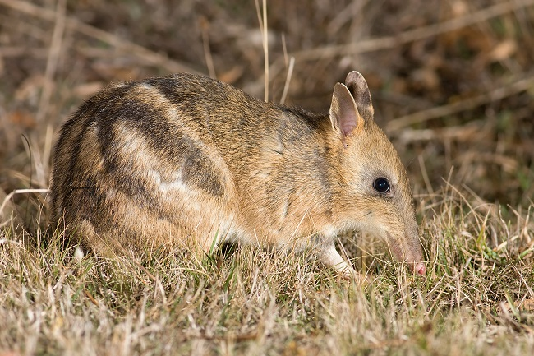
Eastern barred bandicoot - JJ Harrison

EPBC Act listed bandicoot species
Classification | Species
Extinct | Pig-footed bandicoot (Chaeropus ecaudatus); western barred bandicoot (mainland) (Perameles bougainville fasciata); desert bandicoot (Perameles eremiana)
Endangered | Southern brown bandicoot (eastern) (Isoodon obesulus obesulus); western barred bandicoot (Shark Bay) (Perameles bougainville bougainville); eastern barred bandicoot (mainland) (Perameles gunnii unnamed subsp.)
Vulnerable | Golden bandicoot (mainland) (Isoodon auratus auratus); Golden bandicoot (Barrow Island) (Isoodon auratus barrowensis); southern brown bandicoot (Nuyts Archipelago) (Isoodon obesulus nauticus); eastern barred bandicoot (Tasmania) (Perameles gunnii gunnii)

Bandicoots are a group of approximately 20 species of small, solitary, omnivorous marsupials which, aside from three species found in New Guinea, are endemic to Australia. They are primarily nocturnal and live in a wide variety of habitats including rainforests, heathlands, and wet and dry woodlands, building nests in shallow, leaf litter lined holes in the ground - often hidden under debris, with the presence of a dense understory being important to support, disperse and provide predation protection. A variety of food sources are eaten by these species which are perhaps best known for the snout-shaped holes they leave around the place, including insects and insect larvae, worms, spiders, plant tubers, roots and truffle-like fungi.

Although the majority of bandicoot species are very restricted in their geographic range, some, such as the southern brown bandicoot, have a relatively broad distribution across Australia with several distinct subspecies occupying different ecological niches throughout their range. However even these species which have a proven ability to adapt are under great pressure, with the current area of occurrence of southern brown bandicoots having considerably contracted since European colonisation. The species is now very patchily distributed in isolated populations across their former range.

As outlined in the table above, the Environment Protection and Biodiversity Conservation Act, 1999 (EPBC Act) list of threatened fauna records that three species (the pig-footed bandicoot, mainland subspecies of western barred bandicoot, and desert bandicoot) have become extinct since European settlement of Australia. And with another three species classified as endangered and four as vulnerable, it is clear that bandicoots are particularly susceptible to a number of threats present in their habitat range.

Very few native animals prey on bandicoots, with owls, quolls and dingoes being their only significant natural predators. However introduced animals such as foxes, dogs, and both domestic and feral cats combine to pose a significant threat to several bandicoot species. Furthermore, road construction, housing developments and other pressures attributable to an expanding human population have displaced and severely fragmented bandicoot populations, increasing their vulnerability to the threats of predators and motor vehicles.

Due to the diverse range of habitat types represented by Australian WLT sanctuaries, protection efforts for the large majority of bandicoot species endemic to Australia are enhanced through our members' dedication to providing a safe place for native wildlife. Additionally, the HSI/WLT Threatened Ecological Communities Nomination Program continues to seek protection for large areas of vegetation under threat, assisting the survival prospects for native species such as bandicoots in a world which, for our wildlife, is ever shrinking.

Did you know?
The northern beaches of Sydney are one of the last strongholds for long-nosed bandicoots in the region, with a population in Sydney Harbour National Park at Manly being listed as Endangered under the NSW Threatened Species Conservation Act, 1995 (TSC Act) following a joint NGO / Humane Society International nomination in 1996 – one of the first endangered population listings in NSW.

https://www.wildlifelandtrust.org.au/index.php/australian-wildlife-profiles/304-bandicoots

The Northern Rivers contains
Isoodon macrourus Northern brown bandicoot
Isoodon obesulus Southern brown bandicoot Endangered
Perameles gunnii Eastern barred bandicoot Endangered
Perameles nasuta Long-nosed bandicoot
https://www.environment.gov.au/system/files/pages/bbe858b1-bbc4-4127-a087-ef8e3af84995/files/species-nsw-northern-rivers.pdf

